Lab 11 and 12

Objectives

The main objective of this lab is to be able to use databases C# applications using ADO.Net classes and Microsoft SQL Server and Microsoft Access. We will use data access components tools to connect to, retrieve and update data in database. We will explore how we can leverage the built-in capabilities of ADO .NET to extract and manipulate data as well as insert, update and delete data in SQL Server. With this, we will take a look at CurrencyManager object to navigate the records in our bound controls.

Program 1
This simple application how to create database connectivity in C # application.

Steps
Create a Database consisting of four tables containing necessary attributes of these tables along with the connectivity’s .
- Department.
- Teachers.
- Student.
- Subjects
- Courses
- Program

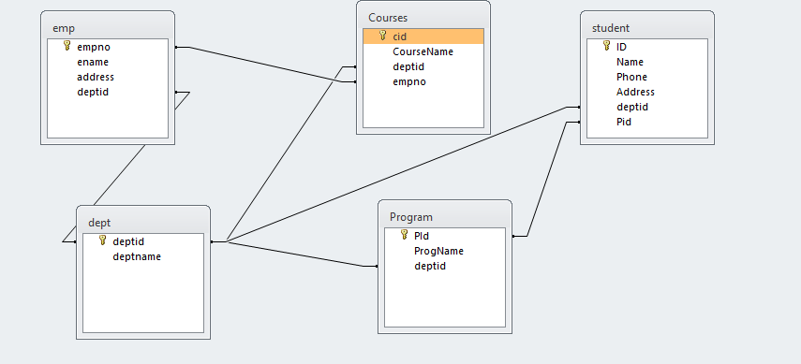
- Start a new Windows Application project. Design GUI as shown below:

- As this in untyped connection, we have to import System.Data.Oledb name space
- We’ll declare connection, Data Adapter, Data Set and an integer variable as globel:

OleDbConnection con = new OleDbConnection("Provider=Microsoft.jet.Oledb.4.0;Data Source= e:\SalesDatabase.mdb;");
OleDbDataAdapter adap = new OleDbDataAdapter("select * from student", "Provider=Microsoft.jet.Oledb.4.0;Data Source=e:/std.mdb;");
DataSet d = new DataSet("student");

Int intCurrentIndex =0;

- Data Adapter acts as a bridge between application and connection. For that a Data Adapter must know which database and what table(s) to use as we’ll use Data Adapter to fill our Data Set: On form’s load event, write following line of code:

da.Fill(ds);
‘DS is the name of Data Set

Do It Yourself: Code click events of “<” button and “>>” button yourself.

Program 2
This simple application demonstrates How to Use DataGridView control to display data:

- Open a new form and place DataGrid Control and a Button on your form.
- As in previous example import Oledb namespace and declare Connection, Data Adapter and Data Set as global variables.
- Go to Load Event of your for and enter the following coding:

string constr = "Provider=Microsoft.Jet.Oledb.4.0; Data source =e:/std.mdb";
OleDbConnection con = new OleDbConnection(constr);
string strsql = "select * from student";
OleDbDataAdapter adap = new OleDbDataAdapter(strsql, con);
DataSet d1 = new DataSet("student");
con.Open();
adap.Fill(d1, "student");
dataGrid1.DataSource = d1;

- Save and execute your work.

Program 3:

Enhance your form according to snapshot:( Data Manipulation )
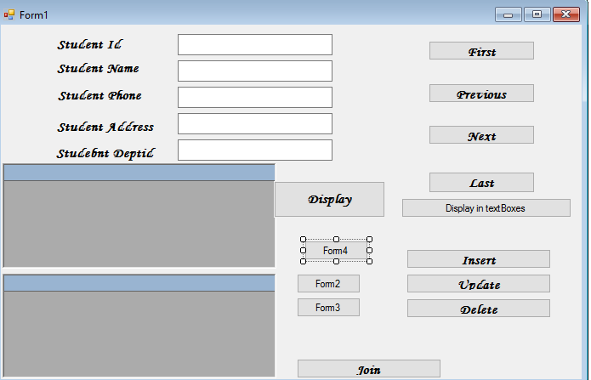

Solution:
OleDbConnection con = new OleDbConnection("Provider=Microsoft.Jet.OLEDB.4.0; Data source=f:/std.mdb");
DataSet d1 = new DataSet("student");
int counter = 0;
private void button1_Click(object sender, EventArgs e)
{

}

private void button6_Click(object sender, EventArgs e)
{

textBox1.Text = d1.Tables[0].Rows[0]["ID"].ToString();
textBox2.Text = d1.Tables[0].Rows[0]["Name"].ToString();
textBox3.Text = d1.Tables[0].Rows[0]["Phone"].ToString();
textBox4.Text = d1.Tables[0].Rows[0]["Address"].ToString();
textBox5.Text = d1.Tables[0].Rows[0]["deptid"].ToString();

}

private void Form1_Load(object sender, EventArgs e)
{
con.Open();

}

private void button2_Click(object sender, EventArgs e)
{
if (counter > 0)
{
counter = 0;

textBox1.Text = d1.Tables[0].Rows[counter]["ID"].ToString();
textBox2.Text = d1.Tables[0].Rows[counter]["Name"].ToString();
textBox3.Text = d1.Tables[0].Rows[counter]["Phone"].ToString();
textBox4.Text = d1.Tables[0].Rows[counter]["Address"].ToString();
textBox5.Text = d1.Tables[0].Rows[counter]["deptid"].ToString();

}
}

private void button3_Click(object sender, EventArgs e)
{
if (counter > 0)
{
counter = counter - 1;
textBox1.Text = d1.Tables[0].Rows[counter]["ID"].ToString();
textBox2.Text = d1.Tables[0].Rows[counter]["Name"].ToString();
textBox3.Text = d1.Tables[0].Rows[counter]["Phone"].ToString();
textBox4.Text = d1.Tables[0].Rows[counter]["Address"].ToString();
textBox5.Text = d1.Tables[0].Rows[counter]["deptid"].ToString();
}
else
{
MessageBox.Show(" U are lready on the first record");
}
}

private void button4_Click(object sender, EventArgs e)
{
if (counter < d1.Tables[0].Rows.Count - 1)
{
counter = counter + 1;
textBox1.Text = d1.Tables[0].Rows[counter]["ID"].ToString();
textBox2.Text = d1.Tables[0].Rows[counter]["Name"].ToString();
textBox3.Text = d1.Tables[0].Rows[counter]["Phone"].ToString();
textBox4.Text = d1.Tables[0].Rows[counter]["Address"].ToString();
textBox5.Text = d1.Tables[0].Rows[counter]["deptid"].ToString();
}
}

private void button5_Click(object sender, EventArgs e)
{
if (counter < d1.Tables[0].Rows.Count - 1)
{
counter = d1.Tables[0].Rows.Count - 1;
textBox1.Text = d1.Tables[0].Rows[counter]["ID"].ToString();
textBox2.Text = d1.Tables[0].Rows[counter]["Name"].ToString();
textBox3.Text = d1.Tables[0].Rows[counter]["Phone"].ToString();
textBox4.Text = d1.Tables[0].Rows[counter]["Address"].ToString();
textBox5.Text = d1.Tables[0].Rows[counter]["deptid"].ToString();
}
}

private void button7_Click(object sender, EventArgs e)
{

OleDbDataAdapter adap1 = new OleDbDataAdapter(" Select student.ID , dept.deptid from student inner join dept on dept.deptid=student.deptid ", con);
DataSet d2 = new DataSet();
adap1.Fill(d2,"student");
dataGrid1.DataSource = d2;
OleDbDataAdapter adap2 = new OleDbDataAdapter("select Courses.CourseName,emp.ename from emp inner join courses on emp.empno=courses.empno", con);

adap2.Fill(d2,"emp");
dataGrid2.DataSource=d2;

}

private void button8_Click(object sender, EventArgs e)
{
OleDbCommand com1 = new OleDbCommand("Insert into student(ID,Name,Phone,Address,deptid) values(' " + textBox1.Text + " ',' " + textBox2.Text + " ',' " + textBox3.Text + " ',' " + textBox4.Text + " ',' " + textBox5.Text + " ')", con);
com1.ExecuteNonQuery();
MessageBox.Show("One record has been added");
}

private void button10_Click(object sender, EventArgs e)
{
OleDbCommand com2 = new OleDbCommand("DELETE FROM student where ID = '" + textBox1.Text + " '", con);
com2.ExecuteNonQuery();
MessageBox.Show("One record has been deleted ");

}

private void button11_Click(object sender, EventArgs e)
{

Form2 f2 = new Form2();
f2.Show();
}

private void button9_Click(object sender, EventArgs e)
{
OleDbCommand com3 = new OleDbCommand("UPDATE student set Address='Lahore' where ID= '" + textBox1.Text + " ' ", con);

com3.ExecuteNonQuery();
MessageBox.Show(" One record has been updated");

}

private void button12_Click(object sender, EventArgs e)
{
Form3 f3 = new Form3();
f3.Show();

}

private void button13_Click(object sender, EventArgs e)
{
Form4 f4 = new Form4();
f4.Show();
}
}
}
Task 1: Design this interface for second Form.

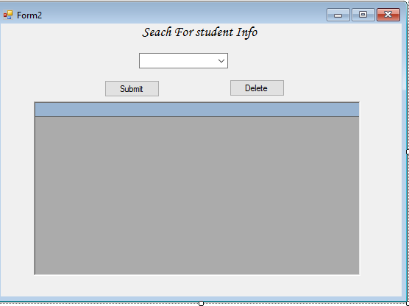

Task 2: : Design this interface for third form
And write down necessary coding

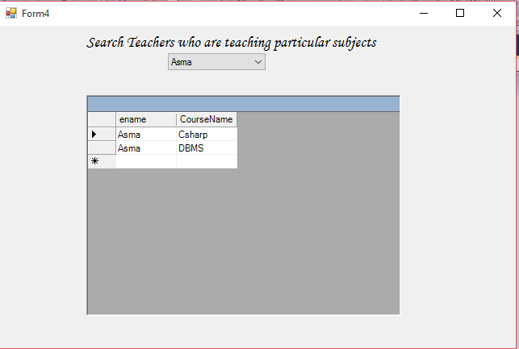

Program 5:

This database application demonstrates the use of ADO.Net classes using Access Database.

Steps

1. For this example we have created MS-ACCESS database named Csharp1.mdb. The table structure for the bank table used in this example is show below:
The properties of the fields are as follows
- AccountNo - Number - Long Integer
- Name - string
- BranchCode - int
- AccountType - int
- ATMReq - int
- Balance - Number - Decimal
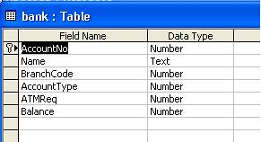

- Create a new Windows Application project. From toolbox’s Data tab, select OleDbDataAdapter component and configure it to establish connection with your database.

- Design your GUI as shown below:

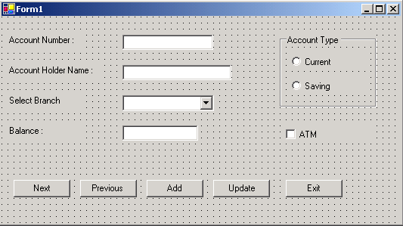

- In this application, we will be working with individual data bound controls.

- Select first Textbox control on your form.

- Open DataBinding section on control’s Properties window, locate the Text item, and expand its list of possible settings. Select the one you want to display in your control as shown below:

